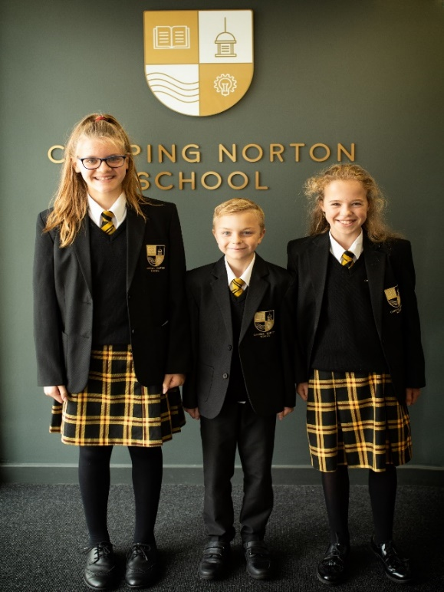
CNS Uniform & Appearance Guide
2021-22

Our Values and Beliefs
Our school uniform celebrates our belonging to a like-minded community that is bonded by common values, aspirations and goals – to be the best we can be. We seek the highest possible standards in all aspects of our life at this school and seek to work closely with parents, carers and students to make this a reality.
Why do schools have uniforms?
- School uniforms are a traditional feature in nine out of ten UK schools.
- School uniform can foster a sense of belonging and community, whilst removing any visual indicators of a child’s personal circumstances.
- Whilst there is little evidence to suggest that uniform will help achieve higher grades, its widespread use and endorsement is certainly evidence of its positive impact.
Why is school uniform important to us at CNS?
- Our purpose as a school is two-fold: to enable every child to meet their academic potential AND to develop young people who are happy, confident and optimistic about their future, whatever their personal circumstances.
- We strongly believe that wearing a smart school uniform, which fosters a sense of pride and belonging, is essential to fulfilling both of these purposes for our students.
- As with all school rules, which are designed to promote the success and well-being of our students, school uniform can only be a positive feature if it is worn consistently and correctly.
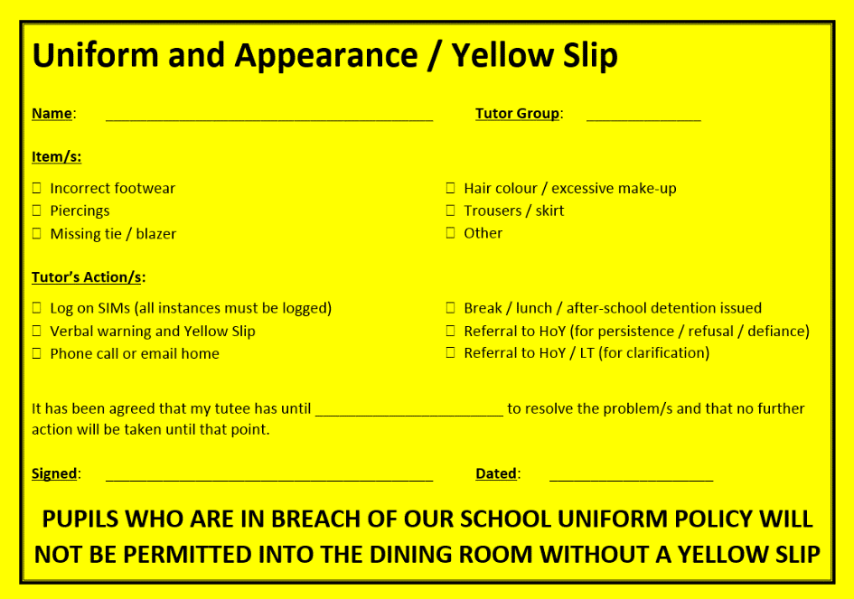
How is uniform monitored?
- Every morning, tutors will check uniform. In all subsequent lessons, teachers will be monitoring uniform as students arrive and leave.
- In occasional circumstances, if a student has brought a valid problem with uniform to the tutor’s attention, they will be issued with a Yellow Slip to avoid being sanctioned throughout the day by other teachers.
What if families have problems providing uniforms?
- All problems can be solved by communication – please contact the school with any concerns you have. In the first instance please speak to your son or daughter’s tutor.
- The school deals sensitively with uniform issues that arise out of financial pressures – families should contact the family support worker (cbudd@chippingnortonschool.org) to find out ways that we can help.
- If in doubt about an item of clothing or pair of shoes, please ask us before you buy them or open and wear them. Either visit or call the school or simply email us to help you. It is always best to check a store’s refund and exchange policy before purchasing any item that may turn out to be unacceptable.
What if students breach the policy?
- We issue reasonable and proportionate sanctions at Chipping Norton School. This includes detentions for occasional breaches or more serious sanctions where a refusal to adhere to the policy represents a broader act of defiance.
What is the role of parents and carers?
- In choosing to send a child to Chipping Norton School, parents and carers are embracing and supporting our values, ethos and rules.
- As with all school rules, we look to parents and carers to help us enforce consistent application of this policy and not seek exceptions and special treatment for their son or daughter, unless there are very strong and mutually agreed medical or other reasons.

Uniform and Appearance Guidelines. If in doubt, please ask.

Blazers and Coats – available through Price and Buckland (enquiries@price-buckland.co.uk)
- Black blazer with school badge.
- Plain coats - logos must be discreet.
- No hoodies under any circumstances worn above or beneath garments.
- No caps but sensible winter hats may be worn (outdoors) during the colder months.

Shirts, Ties and Jumpers - available through Price and Buckland (enquiries@price-buckland.co.uk)
- Either a white shirt with formal collar - tucked in neatly at all times – with black and gold clip-on school tie (same tie for all students).
- Or a badged white blouse without a school tie.
- Optional: Black V-neck sweater with school badge.

Trousers and Skirts - skirts available through Price and Buckland (enquiries@price-buckland.co.uk)
- Black tailored trousers (no skinny or spray fit, jeans, studs, chinos, leggings, jeggings, tracksuit bottoms.
- Black and gold tartan patterned ‘2 box pleat’ or ‘kilt’ style skirt. No rolling up and no more than 10cm above the knee.
- Students starting 11 in September 2020 will have the option to continue wearing a black school skirt. Skirts cannot be skintight or more than 10cm above the knee.
- Plain black belts (no large buckles, fabric or colourful designs).
- Plain black or dark grey tights (no patterns and a spare pair in bag suggested).

Footwear
- Plain black leather / synthetic leather type shoes that offer basic protection in wet weather. The shoe must cover the foot and therefore offer basic protection against falling objects or liquids in practical lessons. No heels over 3cm.
- No trainers, boots, pumps, ballet style slip-ons, plimsolls, sling-backs or canvas footwear. Laces must be black (although Velcro and discreet buckles are permitted). No visible branding or logos
- Exceptions permitted only with a medical professional’s letter.

Hair, Jewellery or Piercings
- No unreasonable or extreme haircuts – please check with Leadership Team or Heads of Year before attending barbers / hairdressers if unsure.
- No shaved patterns or lines in the hair or eyebrows.
- Only plain dark coloured hair bands / clips / slides. No other hair accessories (e.g. bows, flowers etc.).
- Hair colouring must be natural hair colour only (i.e. not purple/pink/peroxide/red etc.).
- Jewellery is restricted to a wristwatch and one plain small stud earring in each lobe – no other piercings permitted (no nose, tongue, eyebrow, studs etc.).
- Parents and carers have a duty to ensure that students do not arrive in school with any facial piercings. Any student arriving at school with a facial piercing will be asked to remove it and place them / it in an envelope for safekeeping and collection and discussion with parent / carer.

Make-up
- Make-up must always be subtle – no dark eyeliner, false eyelashes or bright eye shadow.
- Light foundation only.
- No nail varnish or false nails.
- No fake tan, visible body-art or tattoos.

Mobile Phones
- Students will not be sanctioned for bringing a mobile phone into school if: (a) it is unseen and unheard through the school day or (b) they are given permission to use the phone for emergency purposes by their Head of Year or a member of the Leadership Team or staff running after-school clubs.  - All mobile phones must be switched off during the entire school day (8:40am until 3:15pm) and are not permitted to be used or seen at break or lunchtime.  - Headphones / earphones are not permitted under any circumstances.  - Mobile phones are not permitted to be used in classrooms for listening to music. Mobile phones may not be used for research or other educational purposes without the permission of a member of the Leadership Team.  - Telephones are available, free of charge, to contact home via Heads of Year. | On the first occasion, all mobile phones will be confiscated if seen and returned to the student at the end of the day with a warning.  On the second occasion, all mobile phones will be confiscated if seen. The student will also be placed in a detention and the phone will have to be collected by the parent or carer.

School Bag and Equipment
- A suitable school bag that will carry and protect all school books and other equipment.
- Stationery: at least two pens, a pencil, an eraser and a ruler.
- All students are also very strongly encouraged to have highlighter pens, a glue stick, a geometry set and a calculator. These items can be supplied, free of charge, to students whose family is facing financial difficulty.
- All student are very strongly recommended to back their books in clear sticky-back plastic.
- Tutors will carry out regular checks and will make direct contact with parents and carers when a tutee’s readiness for learning is in doubt.
- Detentions may be issued at the discretion of each tutor and Head of Year.

PE Kit – ALL STUDENTS - available through Price and Buckland ( enquiries@price-buckland.co.uk)
ALL STUDENTS | - Black shorts or skort with school badge.  - Indoor top: White PE short-sleeved T-shirt with school badge.  - Black and gold full-length socks.  - Indoor trainers with non-marking soles.  - Outdoor studded boots.  - Highly recommended: gum shield and shin pads.  - Outdoor top: Black and gold sports jersey with school badge.  - Optional: Badged black outdoor fleece jacket / coat.  - Optional: Black Track Pants  - Optional - Black mid-layer top with inner fleece and school badge.  - Optional – Black Base layer leggings (males)  - Optional – Black Sport leggings (females)  All ear piercings must be removed (not taped) during practical lessons, plus watches and jewellery removed and hair tied back. | As with other uniform breaches, students can expect to be placed in a detention by their teachers who have discretion to look at each case on merit.

