Year 6 Geography transition lesson – compassion
Compassion introduction
TASK: Highlight the definition and example of compassion
Compassion: The sympathetic pity and concern for the sufferings or misfortunes of others.
An example of every day compassion is sharing a hug or a smile with someone.
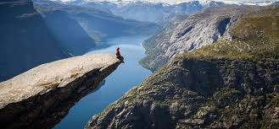
What compassion do we find in geography?
TASK: Highlight the definition of geography.
Geography is the study of places and the relationships between people and their environments.

Examples of compassion in geography
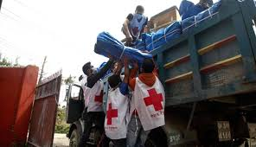
TASK: For each image, label and describe an example of compassion you see in each image.

These aid workers are showing compassion for others as they are packing up tents for people who need them (after an earthquake)

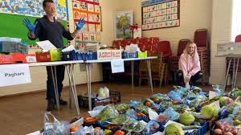
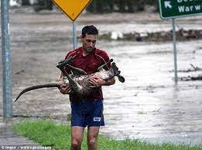
This is an example of compassion
This is an example of compassion

The United Nations: What we can do to be compassionate about the planet
TASK: In the paragraph highlight why the United Nations was set up in 1945.
Almost 8 billion people live in the world in 195 countries and speak thousands of languages. They don’t always get along. The world is full of conflict. After the last major global war, World War 2, ended in 1945, countries decided to get together to try to develop good relationships between nations, so that they could help one another and maintain peace. They formed the United Nations which has its headquarters in New York.
The United Nations: The sustainable development goals
In 2015 the member states of the United Nations decided to put together a series of goals which every country would try to achieve to help make development more sustainable.
The aims of these seventeen Sustainable Development Goals (SDG) are:
• to end poverty,
• to protect the planet and
• to ensure that all people enjoy peace and prosperity.
TASK: Read each sustainable development goal, put them into the correct column below. (Think – what does this goal actually achieve.)

Ending Poverty | Protecting the planet | Promoting peace and prosperity
- No Poverty | 7) Affordable and clean energy | 5) Gender equality

#Challenge: For a total of three goals, explain why they could fit into more than one column.
Goal 1: ________________________
Explain why it could do into two columns: ______________________________________________________
______________________________________________________________________________________________
Goal 2: ________________________
Explain why it could do into two columns: ______________________________________________________
______________________________________________________________________________________________
Goal 3: ________________________
Explain why it could do into two columns: ______________________________________________________
______________________________________________________________________________________________
How successful are the sustainable development goals?
TASK: Using the information below, summarise down to two sentences how successful the sustainable development goals are in 2021?
The 17 Goals were adopted by all UN countries in 2015, as part of the 2030 Agenda for Sustainable Development which set out a 15-year plan to achieve the Goals.
Today, progress is being made in many places, but, overall, action to meet the Goals is not yet advancing at the speed or scale required.
_____________________________________________________________________________________________________________________________________________________________________________________________________________________________________________________________________________________________
To finish
TASK: ‘Countries should work together, e.g. via the United Nations (UN), to try and solve global problems like ending poverty and protecting the planet.’
State whether you agree or disagree with this view, and explain in two full sentences, why you either agree to disagree.

I agree / disagree with this statement. Because: ________________________________________________
_____________________________________________________________________________________________________________________________________________________________________________________________________________________________________________________________________________________________

